**Project Milestone 1 AS-IS Report**

**Centralized Application System:**

**Common Application**

**Grad Gurus, Group 1:**

**Temilade Afolabi**

**Yanyun Bi**

**Ashritha Shetthalli**

**Michael Rogowski**

**Matthew Valdez**

**1. Introduction:**

**a. Identify the Process under discussion** (i.e. the process in scope)

The Common Application (informally known as the Common App) is an undergraduate college admission application that applicants may use to apply to any of more than 700 member colleges and universities in 49 states and the District of Columbia, as well as in Canada, China, and many European countries. On this system Students are allowed to apply for multiple colleges simultaneously at once with nominal application charges. The idea behind the Common App is to try to reduce the barriers that students face when applying to college.

But, Common App is limited to freshman and transfer students looking for an admission to enroll in a bachelor’s degree. Moreover, the Common App allows students to self-report standardized test scores, bur the vast majority of colleges demand direct reporting of scores through the testing agencies.

**b. What is the organizational context?**

**Internal environment:**

➤It is managed by the staff of a not-for-profit membership association (The Common Application, Inc.) and governed by a 13-member volunteer Board of Directors drawn from the ranks of college admission deans and secondary school college guidance counselors.

➤The step-by-step introduction is very clear to help a student apply. The counselor can give some advice according to a student’s practical situation.

➤ Most of the membership college are private.

**External environment:**

➤The Common App started in 1975, and as of September 2017, 747 colleges accept the Common App. Therefore, the admissions officers who read these applications know the forms inside and out.

➤The Common App is free to use and about 45 percent of the member schools do not charge application fees.

➤The platform is popular, but it is not the only one for college applications. There are other applying platforms also. Many schools allow students to apply online through their websites.

**c. Mention any STEEPLE factors that are influential.**

**Social**: Focus is on high school students.

**Technological**: New Common App for transfer students will be available in early 2018.

**Economic**: A non-profit organization.

**Environmental**: It represents almost 700 schools and students do not need to submit application separately.

**Legal**: All information students send is encrypted using TLS.

**Ethical**: Helpful guidance for students applying to colleges/universities.

**d. Who are the major stakeholders?**

➤Students

➤ Parents

➤ Counselors

➤ Colleges/Universities

**e. What are the inputs that trigger the start of the process and the outputs that signal completion of the process?**

**Inputs that trigger the start of the process:**

Student visiting the website and applying to school.

**Output that signals completion of process:**

Common app producing a PDF file including Common Application ID number (CAID).

**f. Provide a high-level diagram of the process**

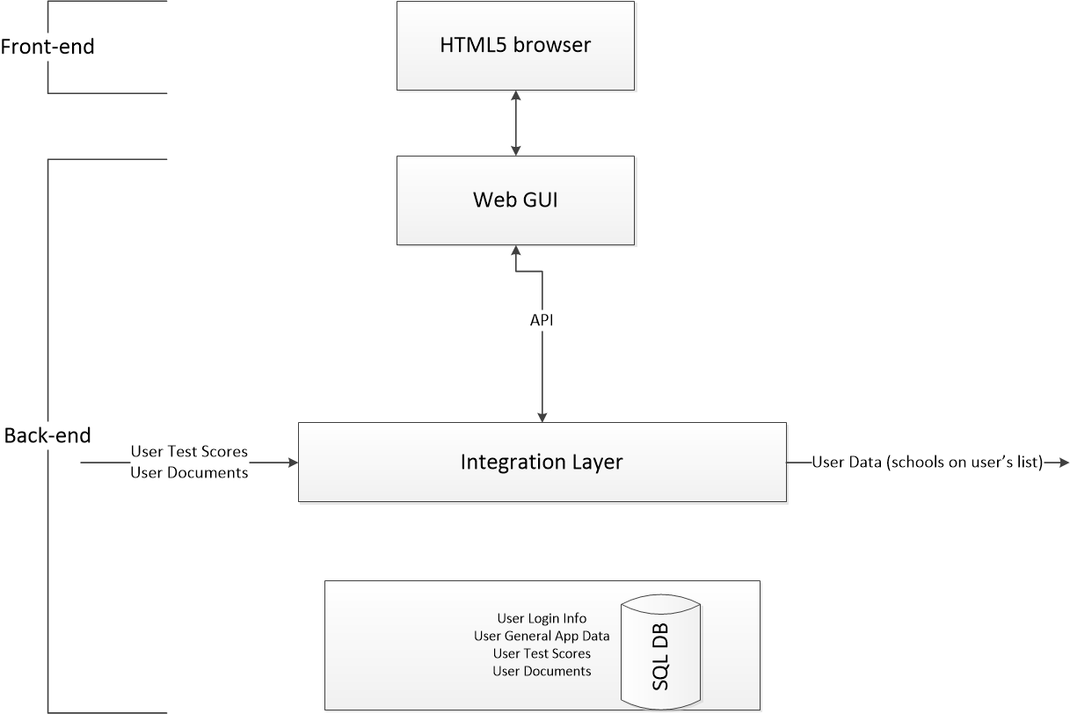

**2. Further Refinement of the Process under Discussion**

**a. Project Scoping Diagram for Process**

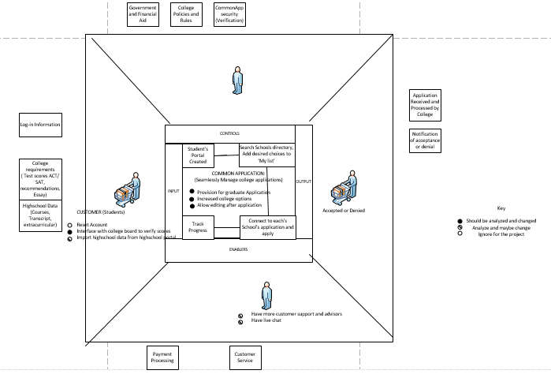

**As-Is Process**

1. Create CommonApp Account

- Username = Email. This is used for correspondence as well;

- Other info needed include: Name, Date of Birth, address and phone number.

2. Search CommonApp Directory of 700 schools from 21 countries offering undergraduate courses and add choices to ‘My colleges’ List.

3. CommonApp connects directly to applications page for each school.

- If not yet decided there is a Virtual Counselor page that offers expert advice on school selections. Featuring tips, video clips, FAQs etc.

4. Requirement Tracker: Understand requirements for each school. Keep track with the tracker worksheet.

- College Name

- Deadline

- Application Fee

- Required Tests

- Recommendations

- Writing requirements

5. Gather general Application Information (The part of the application that is basically same for all schools)

- High school grades and courses

- Extracurricular activities

- Entrance exam scores, exam dates

- Parent/Legal guardian information

Application Dictionary provides help with understanding words used in applications

6. Commence filling out each application.

7. Download commonApp onTrack Mobile app to track progress, add and invite recommenders, create reminders and tasks.

**b. Work System Snapshot**

A work system depicts how participants (human and machine) do work (processes and activities) using information, technology and some other resources to produce specific products and services for internal and/or external customers.

This framework helps to put emphasis and focus on business rather than IT.

* Internal Factors: Processes and activities, participants, information are within the work system
* Internal or External: Customers, products and services may exist within or outside the work system.
* External: Infrastructure, environment and strategies usually are not directly within the work system.

|  |  |  |
| --- | --- | --- |
| ENVIRONMENT  This includes the relevant organizational, cultural, competitive, demographic environment within which the work system operates   * This May include demographical considerations to ensure common app is available in needed languages * Considerations of whether there are similar services and what they are doing differently * School’s requirements of commonApp for partnering and interfacing with the platform | STRATEGIES  This includes strategies at all levels (enterprise, organizational and work system strategies) being aligned.   * In this context schools want to admit qualified students, students want to get into certain schools based on some criteria of their own they’ve also used in selecting and common app wants to help students manage this process and make it as easy as possible. The underlying strategy of common app is to help these two parties achieve their aim. | INFRASTRUCTURE  Human, informational and Technical resources used by the work system but managed outside of the system itself   * Standardized testing boards * Educational boards (especially for college level e.g State/National board of education) * Each School’s admissions office and boards setting admission criteria, deadlines and requirements. * School application systems |
| Customers | Products & Services | Processes and activities |
| Refers to the people using or products and services of the work system.   * High School Seniors applying to colleges | All outputs of the commonApp that directly contribute to students being able to achieve seamless application   * A platform to manage college applications with interface to 700 schools across the globe. * Expert Virtual Counselor on all things college. | All steps involved in production of final products and services   * Creating a personal common app account * Adding schools to dashboards * Interfacing with applications for different schools and completing them * Getting expert college selection advice from the |
| Participants | Information | Technology |
| People and machines that perform the work   * Common app (Platform and administrators) * Virtual Advisor experts * Students using common App | Information used and created as participants do their work   * List of schools partnered with commonApp * Account information/ contact information of commonApp users. | Tools used to bring provide or use the products and services of the work system.   * Desk/Laptop * Smart phone for companion mobile app * Databases to store list of partner schools, deadline info, and other requirements for all 700 schools * Secure interface to redirect students to schools application pages |

**3. What are the “Problems” or “Opportunities” with the Current Process?**

Few of the notable problems or limitations of Common App are as follows:

· **Not applicable for Graduate admission application process**

Common App is an undergraduate admission application that can be used to apply to any of its member colleges and universities around the world. So, for now Common app is limited to freshman and transfer students looking for an admission to enroll in a bachelor’s degree.

· **Only allows self-reporting of test scores**

Although the Common App allows students to self-report standardized test scores, the vast majority of colleges demand direct reporting of scores through the testing agencies. In this regard, Common App has failed to address the issue of duplication in process.

· **Limited to certain geographical locations and member institutes.**

Though Common App claims to be that application system which allows you to explore and apply to schools around the world, the ground reality is that Common App features only certain colleges, which are in United States, Canada, China and Europe. Not to forget the fact that students can add colleges limited to 20 and which share partnership with Common App.

· **Renders no option to recall or edit application once after it has been submitted.**

Common App allows you to edit or delete an application from your dashboard as far as it is not yet submitted. However, an application cannot be recalled or asked for editing once it has been submitted to the college. If in case the student wants to do changes to the application, then it becomes his/her responsibility to contact the college directly asking for privilege to correct or update the information on application. Common App does not render any support in making these changes.

**Gap Analysis Model:**

SERVQUAL (service quality gap model) is a gap method in service quality measurement that can be used to identify the gaps between customer expectation and the actual services provided at different stages of service delivery. This model was developed by Parasuraman, Zeithalm, and Berry in 1985 who were able to identify five different gaps: Applying Gap Analysis to Common App, here are the five Gaps worth noticing.

**Gap 1:** The Knowledge Gap

The gap between the customer needs or expectation and management’s definition of these needs. Common App fails to define and address the actual issues of college application, which leads to knowledge gap.

**Gap 2:** The Delivery Gap

The gap between the service quality specification and service delivery. Common App lacks to deliver qualitative process of application by limiting features to not to edit application and not providing any direct support to customer in this regard which leads to Delivery gap.

**Gap 3:** The Policy Gap

The gap between the management perception and service quality needs or expectation and managements

**Gap 4:** The Communication Gap

The gap between the service delivery and external communications. Common App has observed to fail in making right contact with external testing agencies and non – member colleges to accept application submitted through Common App, which leads to Communication Gap.

**Gap 5:** The Customer Gap

The gap between the customer expectation and perception. As a new user with no or little exposure to Common App, I would presume that the App has all necessary features to be a perfect app making overall application process to be easy and seamless. But by time I realize the limitation of app (i.e. only for undergraduate application, limited to 20 colleges only, only self-reporting of scores) my expectations are fallen apart which can be categorized to Customer Gap.

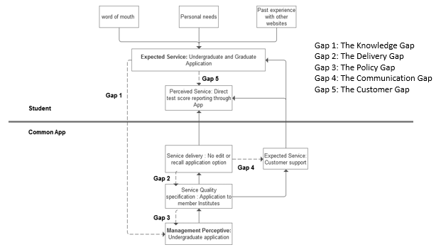

**Product Improvements:**

Now that we have discussed what the Common App actually is, given a detailed analysis of its process flow, and provided problems with its current implementation, it is time to shift our focus towards improvements. The first product improvement that we propose is Graduate School admission capabilities. Earlier, we discussed that while the Common App is a centralized application process for undergraduate admissions, a similar product is non-existent for Graduate Program admissions. In the account creation page, we would add an 'Undergraduate/Graduate' selection option. So if you have an 'undergraduate account', everything would stay the same. The Process Flow would be identical. However, if you have a 'graduate' account, things would change but only slightly. So, when searching for schools, you will now be pointed to schools' graduate programs. Upon selecting a school, you will now be provided with their graduate admissions requirements. This will include GRE's and TOEFL's, instead of SAT's. The next product improvement we propose is to only allow for reporting of scores through the testing agencies. Users can currently self-report scores, which we believe is an unnecessary function. This allows for users to be completely deceitful about the scores they have received on exams. Also, how trustworthy are schools going to be of self-reported scores by users, even if they were being honest? Another problem we wanted to address was the issue of coverage. We decided that the fact that the Common App features only certain schools in certain countries warranted discussion and analysis. However, upon further discussion, we have decided that this problem is ultimately out of scope. Featuring schools on the Common App would take collaboration between the Common App and those desired schools, which is something that we have no control over.

**Works Cited**

* [www.commonapp.org](http://www.commonapp.org)
* <http://njit2.mrooms.net/pluginfile.php/899258/mod_resource/content/1/Alter-WSM-Systemns_Thinking_for_Bus_Profs-Jan-2011.pdf>
* <http://njit2.mrooms.net/pluginfile.php/899257/mod_resource/content/1/Alter-Validating_Work_System_Principles-Jan-2010.pdf>
* Paul Harmon*, Business Process Change: A Guide for Business Managers and BPM and Six Sigma Professionals*, 2nd Edition, Morgan Kaufmann, 2007.